**Time series using ARIMA model**

A time series is a set of observations taken at a specified times usually at equal intervals.

It is used to predict the future values based on the previous observed values.

APPLICAIONS

* BUSINESS FORECASTING
* UNDERSTAND THE PAST BEHAVIOR
* PLAN FUTURE
* EVALUATE CURRENT ACCOMPLISHMENT

COMPONENTS OF TIMES SERIES (pattern swings)

* TREND – movement to over a lower or higher (higher trend, Lower Trend, stationary),

Happens for some time and disappears.

* SEASONALITY - repeating patten in fixed time periods
* IRREGULATITY – noise, non repeating, irregular patterns are observed, Random variation happens in this time series
* CYCLIC – time series repeating up and down movement , over more than a year, no fixed pattern

**When not to apply time series analysis:**

* **When value are constant** – sales of ,no of coffee is 500 again sales is same 500 for next month we cannot apply and to predict for next month.
* **Values in the form of functions -**  sin(x) and cos(x) as no point of calculating if it is formulated functions.

**WHAT IS SATONARITY?**

Time series has a particular behavior over time, there is a very high probability that it will follow the same in future.

**Methods to remove stationarity**

* Constant mean
* Constant Variance
* Auto covariance that should not depend on time

**When series is in stationary we can apply time series**

Rolling statistics and augmented Dickyfuller test

**Rolling statistics:**

Plot the moving average or moving variance and see if it varies with time.

More of a visual technique.

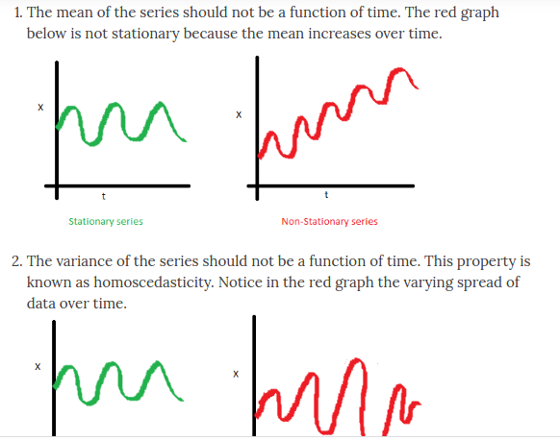

**HOMOSCEDASTICITY IS THE PROPETY WHERE VARIANCE INCREASES OVER A TIME PERIOD.**

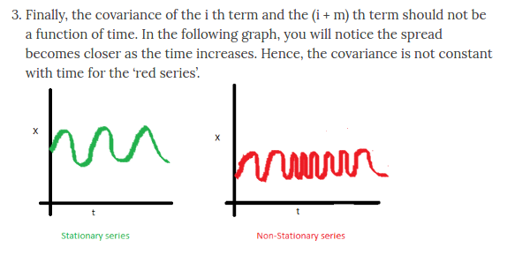

If a time series is stationary and has a particular behavior over a given time interval, then it is safe to assume that it will have same behavior at some later point in time. Most statistical modeling methods assume or require the time series to be stationary.

**ADCF Test:**

Null hypothesis that the TS is non-stationary. The test results comprises of a test statistic and some critical value note : if the test statistic is less than critical value we can reject the null hypothesis and say that the series is stationary

**ARIMA Model (Auto regressive + Moving Average )**

**Auto Correlation Function (ACF)**: The **correlation between** the observations at the **current point in time** and **the observations at all previous points in time**. We can use **ACF to determine the optimal number of MA terms**. MA is the correlation between the auto regressive MODEL HAS THREE PARAMETERS (p,d,q). Three integers (p, d, q) are typically used to parameterize ARIMA models. p: number of autoregressive terms (AR order) d: number of no seasonal differences (differencing order) q: number of moving-average terms (MA order).

**Partial Auto Correlation Function (PACF**) As the name implies, PACF is a subset of ACF. PACF expresses the correlation between observations made at two points in time while accounting for any influence from other data points. We can use **PACF to determine the optimal number of terms to use in the AR model.** The number of terms determines the order of the model.